

YEAR: 10

SUBJECT: Science

TEST: Genetics
TIME: 60 minutes
QUESTIONS: 25 Multiple Choice
7 Short Answers
1 Extended Answer
TOTAL MARKS: 60

DO NOT WRITE ON OR MARK THIS PAPER
SECTION ONE—MULTIPLE CHOICE (25 marks)

This section has 25 questions. Answer all questions on the separate Multiple-choice Answer Sheet provided.

1. Recall the number of chromosomes contained by each human egg or sperm

- 23 chromosomes
- 46 chromosomes
- 23 pairs of chromosomes
- a diploid number of chromosomes

2. The gametes of a fruit fly have four chromosomes. What is the diploid number for the fruit fly?

- 2
- 4
- 6
- 8

3. The structure of DNA may be described as a twisted ladder. Recall what forms the upright parts of the ladder.

a) Alternating sugar and phosphate units
b) Nitrogen bases
c) Amino acids
d) Protein

4. Recall that the number of chromosomes in cells after meiosis, compared to the original cell, is

- double
- same
- half
- quarter

5. Meiosis is also referred to as ‘reduction division’ because it produces daughter cells containing the haploid number of chromosomes. Propose where meiosis would typically occur in, the:

- division of skin cells
- production of gametes
- replication of red blood cells
- replacement of damaged muscle cells

6. Chromosomes are found in the nucleus of:

- most cells of your body
- brain cells only
- reproductive cells only
- stem cells hat have not yet differentiated

7. In a certain organism’s DNA, 10% of the bases are thymine. Calculate the percentage of bases that would be guanine:

- 10%
- 40%
- 80%
- 90%

8. In humans, albinism (a total lack of pigmentation) is inherited as a recessive trait. If an albino man and a non-albino woman (whose father is albino) have a child, calculate the probability that the child is albino.

- 0
- ½
- 1
- ¼

9. If a gorilla has 22 pairs of chromosomes in a skin cell, how many chromosomes are there in the gorilla's sperm?
a) 11 chromosomes
b) 11 pairs of chromosomes
c) 22 chromosomes
d) 22 pairs of chromosomes

10

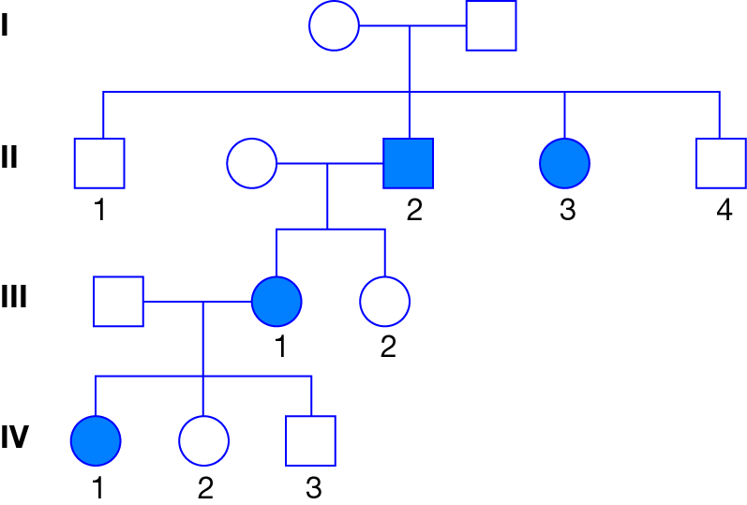

The pedigree above shows the inheritance of a disease (shaded) caused by a recessive gene ‘g’. Those with the dominant gene ‘G’ do not show the disease. Identify the genotypes of the following individuals in order:

Generation II number 3; Generation III male; Generation IV number 2.

a) Gg, gg, Gg
b) gg, Gg, Gg
c) Gg, Gg, Gg
d) gg, gg, Gg

11. Half of a strand of DNA bases is shown below.

ACGTCAATGCATG

Identify the complementary DNA strand:

- TGCAGTCACCTAC
- TCCAGTTACGTAA
- TGCAGTTACGTAC
- TGCAGATACTTAC

12. Red-green colour-blindness is an X-linked recessive disorder. A mother with this condition will pass this allele to

- her daughters only
- all of her children
- her sons only
- none of her children

13. An allele is best defined as

- a lethal recessive phenotype
- a lethal dominant phenotype
- a type of gene found only on the sex chromosome
- an alternative form of gene at a given locus

14. If women with blood group AB marries a man with blood group O, what are the chances of the first child having blood group B?

- 0%
- 25%
- 50%
- 75%

15. The basic unit of inheritance is called a

a) zygote
b) DNA
c) chromosome
d) gene

16. A co-dominant genetic condition is one in which
- the heterozygote show the effect of two different alleles
- there are two possible ways to combine alleles
- the homozygote has inherited different alleles from each parent
- one allele completely hides the effect of another allele.

17. Albinism is inherited as an autosomal recessive trait. If a person has albinism and is married to a person who is heterozygous for the trait there is
- a 50% chance of having a child with albinism
- a 25% chance of having a child with albinism
- a 75% chance of having a child with albinism
- no chance of having an albino child.

18. In humans, a male baby results when the

a) egg is fertilised by a sperm carrying a Y chromosome
b) egg is fertilised very early in the menstrual cycle
c) unfertilised egg contains a Y chromosome
d) the egg is fertilised by a sperm carrying the X chromosome.

19. Which of the following characteristics is definitely solely genetically determined?

a) Blood group
b) Intelligence
c) Ability to succeed at sport
d) Personality.

20. Chromosomes are present in

a) all body cells with a nucleus
b) egg and sperm cells only
c) all cells
d) fertilised egg cells only.

21. If a male parent has the genes TT and a female parent has the genes Tt, then

a) all the offspring will be TT
b) some offspring will be tt
c) some sperm will have t genes
d) some eggs will have T genes.

22. Mary had black hair like her father but her mother has red hair. Mary is pregnant to Bill who has red hair. What is the probability that the child will have red hair? Assume hair colour is determined by a pair of genes at one locus, and that black hair is dominant to red.

a) 0.0
b) 0.25
c) 0.5
d) 1.0

23. The position on a chromosome where a gene is located is called its
- genotype
- locus
- monogenic
- pedigree

24. When two individuals, both heterozygous for a single gene character, are crossed, all the offspring happen to resemble their parents for that character. This genetic trait is referred to as

- genotypic
- dominance
- phenotypic
- recessiveness.

25. The name given to an individual in whom both genes for a characteristic are the same is

a) heterozygous
b) homozygous
c) monohybrid
d) homologous.

NAME:
SECTION ONE—MULTIPLE CHOICE (25 marks)

For each question shade the box to indicate your answer. Use only a blue or black pen to shade the boxes. If you make a mistake, place a cross through that square, do not erase or use correction fluid, and shade your new answer. Marks will not be deducted for incorrect answers. No marks will be given if more than one answer is completed for any question.

1 | a | b | c | d |  | 14 | a | b | c | d
2 | a | b | c | d |  | 15 | a | b | c | d
3 | a | b | c | d |  | 16 | a | b | c | d
4 | a | b | c | d |  | 17 | a | b | c | d
5 | a | b | c | d |  | 18 | a | b | c | d
6 | a | b | c | d |  | 19 | a | b | c | d
7 | a | b | c | d |  | 20 | a | b | c | d
8 | a | b | c | d |  | 21 | a | b | c | d
9 | a | b | c | d |  | 22 | a | b | c | d
10 | a | b | c | d |  | 23 | a | b | c | d
11 | a | b | c | d |  | 24 | a | b | c | d
12 | a | b | c | d |  | 25 | a | b | c | d
13 | a | b | c | d

SECTION TWO—SHORT ANSWER (25 marks)

This section has 7 questions. Answer all questions. Write your answers in the spaces provided.

26
Explain the differences between each pair of terms. (4 marks)

- X chromosome and Y chromosome

- meiosis and mitosis

- genotype and phenotype

- heterozygous and homozygous

27
The diagram below shows a simplified illustration of the stages of meiosis. However, the stages are not in the correct order. Identify the correct order and write the letters corresponding to each stage in order. (2.5 marks)

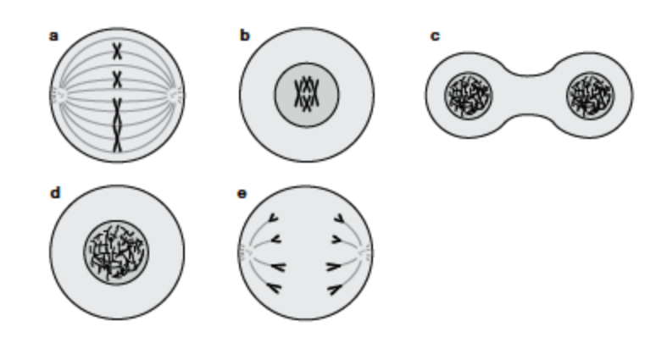

28
Dwarf peas are crossed with heterozygous tall peas. If tall is dominant over dwarf, predict the phenotype and genotype ratios of the F1 generation. Show all working. (4.5 marks)

______________________________________________________________________________

________________________________________________________________________________

________________________________________________________________________________

29
Haemophilia is an X-linked recessive disease. The symbol X^{H} is used to show the normal gene on the X chromosome, and the symbol X^{h} is used to show the recessive gene on the X chromosome.

- State the possible genotype of a:
- Haemophilic male (1 mark)

- Non-haemophilic male (1 mark)

- Non-haemophilic female (1 mark)

- A female may be a ‘carrier’ of the disease. Clarify what is meant by the term carrier and what genotype a ‘carrier’ would display. (3 marks)

30
In relation to the study of genetics:

- State what the letters DNA stand for. (1 mark)

- State what the letters A, C, T and G stand for in a DNA base sequence. (2 marks)

31
Demonstrate how different genotypes can produce the same phenotypes, giving examples using the allele labels ‘M’ and ‘m’. (3 marks)

32. Compare embryonic stem cells and adult stem cells. (2 marks)

_______________________________________________________________________________________

_______________________________________________________________________________________

_______________________________________________________________________________________

SECTION THREE—EXTENDED ANSWER (10 marks)
32
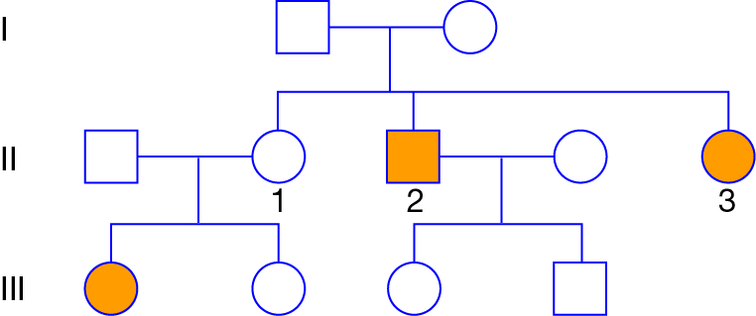
This pedigree shows an inherited condition, which is indicated by the shading.
a) Is this a dominant or recessive condition? ________________________________ (1 mark)

b) Justify your answer. (4 marks) ____________________________________________________________________________________________________________________________________________________________________________________________________________________________________________________________________________________________________________________________________________________________

33. The diagram below shows the stages involved in gene technology using recombinant DNA. Explain what is happening in:
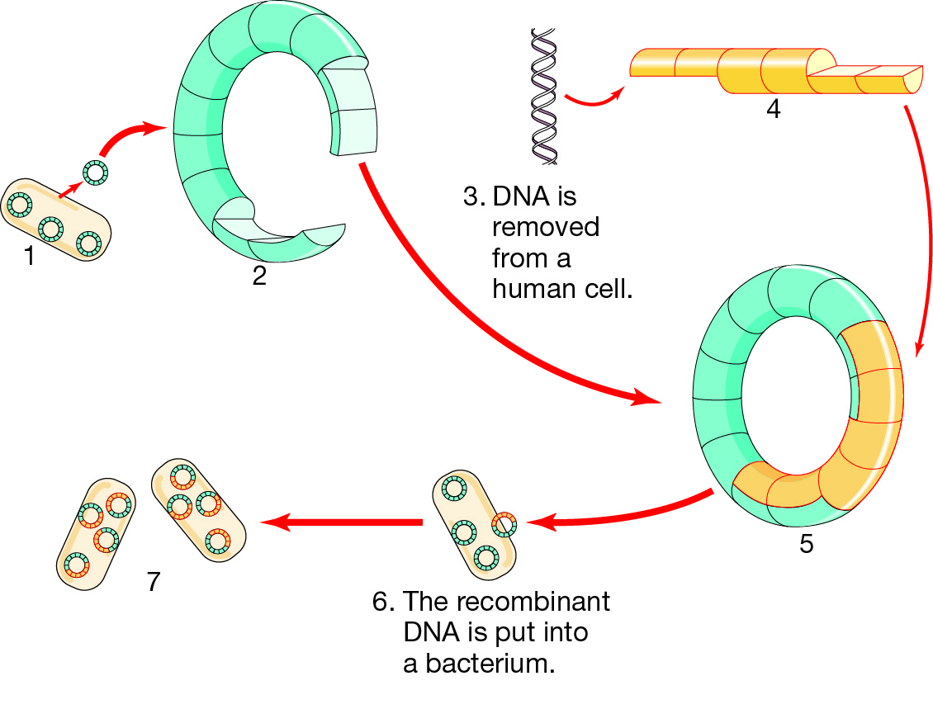

a. Stage 2 (1 mark)
_____________________________________________________________________________
_____________________________________________________________________________

b. Stage 4. (1 mark)
_____________________________________________________________________________
_____________________________________________________________________________

c. Stage 5 (1 mark)
_____________________________________________________________________________
_____________________________________________________________________________

d. Stage 7. (1 mark)
_____________________________________________________________________________
_____________________________________________________________________________

e. Give an example of how this technology is used today. (1 mark)
_____________________________________________________________________________
_____________________________________________________________________________

